***STLC MODEL***

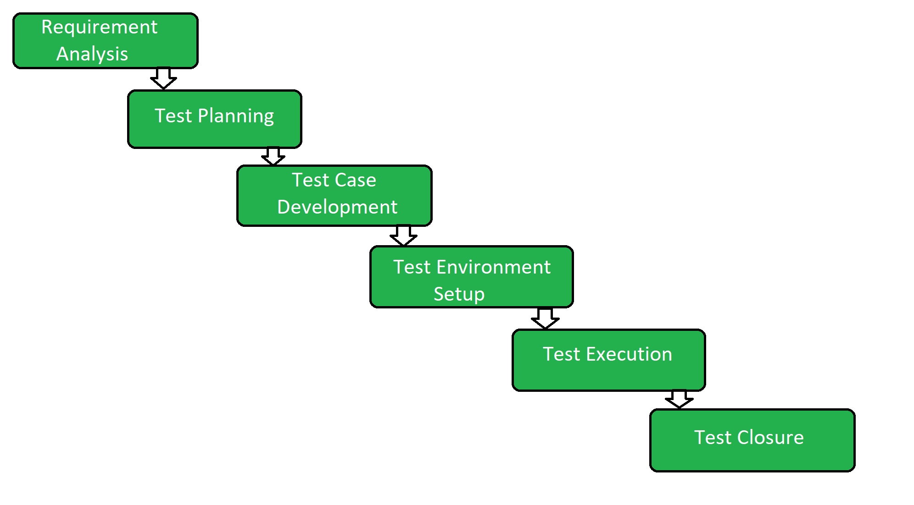

1. Requirement Analysis: The first step of the manual testing procedure is requirement analysis. In this phase, tester analyses requirement document of SDLC (Software Development Life Cycle) to examine requirements stated by the client. After examining the requirements, the tester makes a test plan to check whether the software is meeting the requirements or not.

## Test Planning: Test plan creation is the crucial phase of STLC where all the testing strategies are defined. Tester determines the estimated effort and cost of the entire project. This phase takes place after the successful completion of the **Requirement Analysis Phase**.

## Test Case Development: Testers and developers evaluate the completion criteria of the software based on test coverage, quality, time consumption, cost, and critical business objectives. This phase determines the characteristics and drawbacks of the software. Test cases and bug reports are analyzed in depth to detect the type of defect and its severity.

## Environment setup: Setup of the test environment is an independent activity and can be started along with **Test Case Development**. This is an essential part of the manual testing procedure as without environment testing is not possible. Environment setup requires a group of essential software and hardware to create a test environment.

## Test case Execution: Test case Execution takes place after the successful completion of test planning. In this phase, the testing team starts case development and execution activity. The testing team writes down the detailed test cases, also prepares the test data if required. The prepared test cases are reviewed by peer members of the team or Quality Assurance leader.

## RTM (Requirement Traceability Matrix) is also prepared in this phase. Requirement Traceability Matrix is industry level format, used for tracking requirements. Each test case is mapped with the requirement specification. Backward & forward traceability can be done via RTM

## Test Cycle Closure: The test cycle closure report includes all the documentation related to software design, development, testing results, and defect reports. This phase evaluates the strategy of development, testing procedure, possible defects in order to use these practices in the future if there is a software with the same specification.